Religions & Cults
1: Apologetics, Polemics & Religions

YOUR WAY AND MY WAY
We live in the postmodern age where many believe that there is no truth. “We each must choose what works for us. We can believe opposite things about God and man and both be right.” But for many people, if one way is right, the others must be in error.

If you have found truth, how do you convince someone that you are right? Two ways: one is apologetics and the other is polemics.

Apologetics | To defend oneself, To reply | “I stand on truth, and these are the reasons why.”
Polemics | To box or fight | “Others stand in falsehood, and these are the reasons why.”

THE APPROACH OF THIS STUDY
While we may enjoy apologetics much more, Religions and Cults will be polemic in nature. We are not trying to beat up other religions, but to understand their error so that we can relate to them and win them to Christ. If we don’t know them, we will be afraid of them.

In most cases, we will examine at the history of the cult or religion, review its doctrine and how it compares with a literal understanding of Scripture, and then consider some ways to reach them with the gospel.
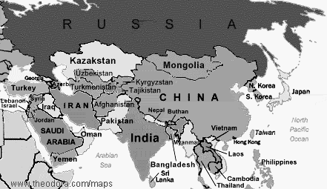

THE RELIGION TREE
Below and on the back are some charts to let you see where and when the world’s religions came about and how a few relate to each other.

Believers are those who follow the one true God of the Bible and are saved by God grace, through faith in Him. Because organized religion is not the way to God, believers may or may not be found in one of these organized religions.

Six Rivers & Six Religious Fountains
Rivers | NILE | JORDAN | EUPHRATES | INDUS | YANG TSE | NAGOYA
Civilizations | EGYPT | PALESTINE | MESOPOTAMIA | PERSIA/INDIA | CHINA | JAPAN
Theism | Polytheism | Monotheism | Polytheism | Polytheistic | Polytheism | Polytheism
Religions | Human Deities  (Egypt) | Judaism (Isaac) | Human Deities  (Babylon, Assyria, Greek, Roman) | Hinduism  Zoroastrianism | Confucianism  Taoism | Shintoism
 |  | Christianity |  | Jainism  Buddhism
 |  | Islam (Ishmael) |  | Sikhism

Prejudice = Ignorance + Fear

TERMS BOX

Polytheism – belief in a multitude of distinct and separate deities

Monotheism – a belief in one personal God

Pantheism – belief in an impersonal God who is identical to the universe (tribal superstition)

CHURCH GENEALOGY
Remember that this a chart of the “Institutional Church” – organizations or groups that consider themselves “Christian.” It does not cover believers and little local churches of believers that have sprung up all over the world outside of the bigger institutions.

Early Church (AD 30-150)

The Ancient Church (AD150-318)

Roman Catholic Church (AD313-Present)

Greek Orthodox Church (1054)

Early Reformation (1300-1500)

Protestant Reformation (1517-1545)

1500

Lutheran Church (1518) of Germany

Anabaptists (1521) of Switz. & Ger.

Russian
Orthodox Church (1589)

LIBERALISM
THE CULTS
GREAT AWAKENING
HOLINESS
Anglican Church (1534)
Reformed Churches (1540) of Ger. & Switz.
Presbyterians (1560) of Scotland, N. Ireland
Plymouth
Brethren (1830)

Dutch Reformed (1640) of Netherlands
Huguenots (1650) of France

Methodists
(1740)
Mormons (1827)
Jehovah’s Witnesses (1850)
Christian Science (1879)
7th Day Adventists (1843)
Grace
Brethren (1950)
Evangelical Free Church
(1885)
Pentecostal Church (1880)
Assemblies of God (1965)
1800
1900
Nazarene
(1894)
1700
1600
Separatists
(1610)
English
Baptists (1615)
American
Baptists (1750)

