Religions & Cults

9: Latter-Day Saints - Doctrine

THE BIBLE
“We believe the Bible (KJV) to be the word of God in so far as it is translated correctly; we also believe the Book of Mormon to be the Word of God.” Mormons believe that the Catholic Church deleted some portions and polluted other portions of the original Bible. Those lost doctrines have been restored by the “inspired works” of the LDS. Smith added large portions to Genesis.
Our View: God would be weak and unwise if mankind could thwart the preservation of His Word. Hebrews 1:1-3 and Luke 24:27 tell us that the OT was written by prophets, and Ephesians 3:5 adds that the apostles wrote the NT, which affirmed the OT and explained the person and work of Christ. Proverbs 30:5-6 and Revelation 22:18-19 warn against adding to or taking away from God’s Word. Revelation was last written and logically concludes the canon.

SOURCES OF AUTHORITY
Mormons believe that their “standard works,” The Book of Mormon, The Pearl of Great Price and Doctrines and Covenants, have no errors and correct errors and omissions in the Bible. Strange that these Books were written in the 1800s in old English!
- The Book of Mormon – This has undergone extensive corrections. Two ancient immigrations:
  - 1. The Jaredites came from Babel in 2,250 B.C., crossed the Pacific in 8 log barges blown by the wind for 344 days to the same shore at the same time along with horses, donkeys and elephants. They set up a huge civilization in Central America. They warred with each other, millions died until only one warrior and one prophet were left. The prophet Ether wrote the story on 24 plates.
  - 2. Lehi, a Jewish prophet from Manasseh, left Jerusalem in 600 B.C. just before Babylon destroyed it, carrying 5 brass plates from Laban containing the Pentateuch, prophecies and Lehi’s genealogy. Nephi, one of his sons, built a boat when they reached the Pacific and they landed in South America. Laman, the other son, and his descendants were rebellious and were cursed with dark skin (ancestors of American Indians). The Nephites were righteous, and Jesus came down to them in A.D. 34 to choose 12 disciples, teach baptism and communion and give the Sermon on the Mount (gospel to the western continents). In A.D. 385, the Lamanites killed all the Nephites in a final battle near Hill Cumorah, NY, except for Moroni whose father’s name was Mormon and had written down the histories on the gold plates.

- The Doctrines and Covenants is a record of 138 revelations Smith allegedly had and contains the doctrines of baptism for the dead, celestial marriage and polygamy (prohibited in the BOM).
“Lucifer wins a great victory when he can get members of the Church to speak against their leaders and to do their own thinking …When our leaders speak, the thinking has been done. When they propose a plan, it is God’s plan.”
June, 1945

- The Pearl of Great Price contains the revision of Genesis 1-6, the Book of Abraham again rewriting Genesis with plural gods, Smith’s history of the Mormons and the Articles.

- The Living Prophet is the head of the LDS Church, President of the Council of Twelve Apostles, and his words are “more vital to us than the standard works.” (said on 2/26/80)

- The Living Oracles or “The Brethren,” the President & the Apostles, are the “Living Oracles” of God “whose utterances are the most recent revelation of God Himself.” Their new revelations supercede all previous ones, even those in the standard works.

Our View: There is no archaeological evidence of the cities, civilizations or languages in the BOM. The 1800s were the high-water mark of archaeology around the world, and Central and South America were undeveloped, so Smith’s story caught imaginations and could not be disproved … back then. Indians are Mongoloid (Hamitic), not Semitic Jews! Mormon scriptures contradict each other and the Bible, and the Living Oracles make the church a moving target.

For contradictions and inaccuracies in Mormon writings, see KOC, pp. 205-212
THE DOCTRINE OF GODS
“We believe in God, the Eternal Father, and His Son Jesus Christ, and in the Holy Ghost.” The BOM says that God is 3 in 1, but Smith’s later writings changed the three persons into separate beings (tri-theism), and then as three among millions of gods (polytheism).
- God The Father - “As man is God was; as God is man may become.” Elohim was the spirit baby of a god from another planet (Kolob). He was not from all eternity. God was birthed in a mortal human body, lived as a man on the earth (as Jesus did), proved himself through testing, and now is exalted as the god of this earth. He is in heaven and has a glorified body, like Jesus.
- Jesus Christ - Jesus and Lucifer were both spirit children of Elohim, as all of us humans also are, Jesus being the firstborn. Jesus’ plan of salvation was approved by the council, and Lucifer rebelled. Jesus was conceived by the union of Elohim’s physical body with Mary’s (debated in the LDS). Jesus was married to Mary and Martha at Cana.

Our View: Christianity is monotheistic to the core. Deuteronomy 6:4, Isaiah 43:10-11, 44:6, 8, 45:5, 21-22, and 1 Corinthians 8:4 say that there is one eternal God, none before and none after. Jesus Christ is a separate person (manifestation) of the same being, coeternal and co-powerful with God the Father and the Holy Spirit. Colossians 2:9 says that in Jesus the fullness of the godhead dwelt in bodily form. See also Hebrews 1:2-3.

THE CREATION
Council of the gods on Kolob sent a committee to form the earth over a period of 6,000 years. Elohim (father) was in charge but Jehovah (Jesus) and Michael the Archangel (Adam) did the work, perhaps helped by Noah, Enoch and Joseph Smith! Young said that Elohim became Adam. The earth was spirit, as was every fish, foul and beast before they were placed here. All creatures will be resurrected.

MANKIND
All humans are the spirit babies, existing “in the beginning” with God and waiting for incarnation. We were given human existence to test us, so that we can be proven. Because the earth was first perfect, it was not a suitable proving ground, so Mormons glorify Eve for taking the forbidden fruit so that sin could begin and mankind could be properly tested. Mormon males can become gods of their own planets and take their wives with them to be eternally pregnant and giving birth to new spirit babies.

Spirit babies who failed to fight Lucifer were punished by being assigned to black bodies (the descendants of Cain) during their mortality. Native Americans were cursed with dark skin because of the Lamanite rebellion. Thus, until 1978 (yup, a new revelation!), no black were allowed and Africa went unevangelized. Mormonism, until lately, has been unashamedly a white supremacist religion.
Our View: We follow the biblical account of creation, plus nothing. Acts 17:26 says that God made from one blood every nation of men. Nothing in the Bible connects skin color with sin. Satan’s lie in the garden was that “you may become gods” (Genesis 3:5).

SALVATION
Jesus was perfect and died to “save”- give everything a resurrection, and open the door to the three heavens for those who must work to get there. Salvation is by faith in Christ, belief in Joseph Smith, baptism by immersion into the Church, obedience to the LDS Church, good works and keeping the commands of God.
Our View: Salvation comes by God’s grace through our enabled faith in Jesus Christ alone, plus nothing (Ephesians 2:8-9, Titus 3:5, 1 John 5:9-15, 19-20).

ESCHATOLOGY (LAST THINGS)
Jesus will come back one day in judgment when the Jews are gathered in the old Jerusalem, and the Mormons are gathered in the new Jerusalem (Missouri). There are three heavens:
- Telestial (lowest) made up of non-Christians who lived in the normal, carnal, wicked manner of the world. Conditions are like our current earth.
- Terrestrial made up of Christians who did not accept the Mormon message, Mormons who did not live up to the LDS ideal, and good men of other religions. It is like an earthly paradise.
- Celestial (highest) made up of the faithful LDS followers who went through celestial marriage in a Mormon Temple. These people become gods with their own planets to populate.

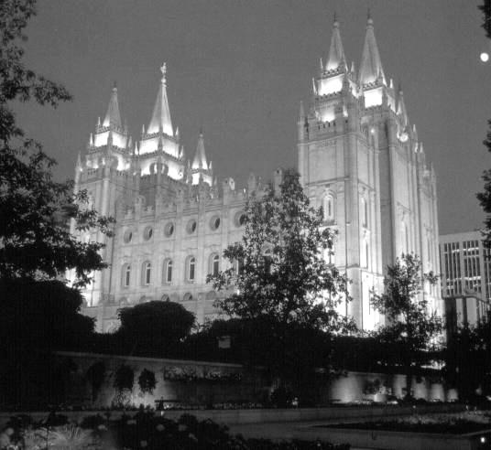
Mormon Temple, Salt Lake City

