Religions & Cults
16: Hinduism

Hinduism is actually a synthesis of the religions of India. It has no founder and has been emerging for five thousand years. Its name comes from the Persian description of religions near the Indus River – “Induism.” There are 700 million Hindus in India and Nepal.

HINDI SCRIPTURES
The Hindu scriptures, known as the Vedas, meaning wisdom, were compiled over many hundreds of years beginning about 1500 B.C. (the time of Moses). They are written in Sanskrit which Hindus believe has power when spoken, and mystics will often memorize slokas and mantras in Sanskrit. The last portions of the Vedas are the Upanishads, which endeavor to synthesize the various Vedic teachings. The most famous story in the Vedas is the epic “Bhagavad-Gita” (written about 200 B.C.) about a soldier named Arjuna and his charioteer Krishna who is the incarnated Hindu god, Vishnu.

BASIC BELIEFS
- God: Hindus worship millions of gods, and believe in the supreme creator-god, Brahman. Brahman is a force; it does not have a personality. Everything seen is temporary, and of no importance; the “realm beyond” really matters. To reach this realm, Hindus believe a person must completely deny himself and the world around him.
Most of Hindi scripture is pantheistic (all of nature and the universe is one divinity - Brahman), but depending on which group a Hindu is from, he may also be monistic (all existence is one substance), panentheistic (God is in creation as a soul is in a body), animistic (gods live in non-human objects like trees, rocks, etc.), polytheistic (333 million gods), henotheistic (worship one God though there may be others), or monotheistic (one God, like in the Bhagavad-Gita). Hindus claim the origin of the trinity in Lord Brahma, Vishnu and Shiva.
- Karma and Samskara: The soul is eternal and keeps reincarnating again and again out of the astral plane to learn all the lessons life in the material world has to offer. Eventually, one reaches “mukti” or enlightenment. Karma is “cause and effect” – bad thoughts or actions create bad karma which comes back to you in time; good actions create good karma. Good and bad also gives you samskara, a tendency or direction which you take with you in the receptacle of works when you die. Dharma is the higher right and wrong.

THREE BASIC HINDU APPROACHES
- Meditationists - They stress the philosophical oneness with the universe through meditation instead of religion or theism. “Yoga” (yoking to God) was started by Maharishi Mahesh Yogi, legitimized as TM in the 70’s to relieve stress, bring inner peace and self-realization, and to engage in astral projection and levitation. Popularized again in the 80’s as New Age meditation and channeling. They believe a human Jesus was enlightened (realised he was God) through meditation. Salvation is to loose yourself in union with the impersonal creative intelligence, the formless Absolute Reality and Truth (God) known as “Brahman.”
- Vishnu Hindus - They stress the worship of Vishnu (same as Krishna & Rama) as a personal Lord and Creator, as the supreme person of the godhead. (Some are the “Hare Krishnas.”) They believe Jesus was Maitriya, Krishna’s son – not Krishna incarnated. Salvation comes by removing karmic debt through devotion to Krishna and doing right actions through multiple incarnations. Modern Hindus stress that all religions approach “God” and are acceptable to Him - “many roads.”
- Shiva Hindus - Stress the worship of Shiva, the destroyer, as the supreme person of the godhead.

Hebrews 9:27 - God has appointed man to die once and then face the judgment.

Hinduism absorbs all other religions; Christianity excludes them (John 14:6).

THE CASTE SYSTEM & REINCARNATION
The Hindu religion contains a strict class (caste) system. Hindus believe that these four classes of people came from the head, arms, thighs and feet of the creator god, Brahman. These four classes are:
- Brahman (priest)
- Kshatriya (warrior and nobleman)
- Vaisya (peasant)
- Sudra (slave)

Hindus believe in reincarnation, that when a person dies he comes back to life in another form, either as another person or as an animal. They also believe that their present caste in life was pre-determined by their actions in previous lives. This belief, called karma, teaches them that every action done will be rewarded or punished in either this life or the next, and these rebirths can go on and on forever.

According to some Hindu commentators on scriptures, a jiva (life-force) is granted a human life only after going through 8,400,000 previous incarnations of lower forms of life -- 2,000,000 as a plant, 900,000 as aquatic, 100,000 as insects, 100,000 as a bird, 300,000 as a cow, 400,000 as a monkey. Many used to believe you then became a woman, then a dog, then a man!

The lowest class of slaves and servants (Sudra) are not allowed to listen to the teachings of the Brahman. In traditional Hinduism the poor are offered no hope of salvation. Women are considered “low class” and are not included in the Hindu system of salvation. As a man’s “property,” a wife is to serve her husband and bear children.

For the higher classes, there are four stages in life. Once a Hindu boy is initiated, he is considered “twice-born” and will live his life in these four stages: first he will be a student, then a head of a house with a wife and children, thirdly, he will be a meditating hermit seeking enlightenment, and lastly, he will be a homeless wanderer who has renounced all things of the world. His four main goals are to become righteous and virtuous, to have material goods, to enjoy life through love, pleasure and appreciation of beauty, and to have spiritual victory over life.

THE SACRED COW
Hindus believe that everything that lives and breathes has a soul (atman) and is a part of the world soul (paramatman). Because of this belief, Hindus will not eat meat or kill any living thing, if possible. They believe the cow is the most giving creature on earth, a gentle creature of abundance; cows, which are thought to be sacred, are allowed to roam the streets and eat freely of the grain, although millions of people are starving. Rats are also allowed to consume huge amounts of grain. As a result of these practices, many people have died. “Ahimsa” is the teaching of non-injury to animals.

SHARING CHRIST WITH HINDUS
- Try to understand the Hindu mindset. Although their beliefs seem complicated, do not be afraid to witness and to share the love of Jesus. Hindus are desperately searching for truth, and are in need of salvation. Know that their emptiness can only be filled by a personal relationship with Jesus Christ.
- Emphasize that there is only ONE Almighty God, and that He became man only once - in Jesus Christ (John 3:16).
- Hindus are aware of their sin and of their need for salvation, although their religion offers them to sure hope. Ghandi (one of Hindu's most respected leaders) wrote, “For it is an unbroken torture to me that I am still so far from Him...I know that it is the evil passions within that keep me so far from Him and yet I cannot get away from them.” Hindus need to know that the penalty for their sin was paid in full by the sacrificial death of Jesus, the Son of God.
- Share how Jesus was born as a simple man, and that He came to bring salvation to ALL people: rich and poor, men and women, and those of all nationalities.
- Show from God’s Word that when a person dies, they are not reincarnated, but they face the judgment of God Almighty and eternal life in either heaven or hell (Hebrew 9:27). Hinduism gives a person no hope or peace, only fear and temporary bliss through meditation. Salvation through Jesus Christ is what they are seeking.



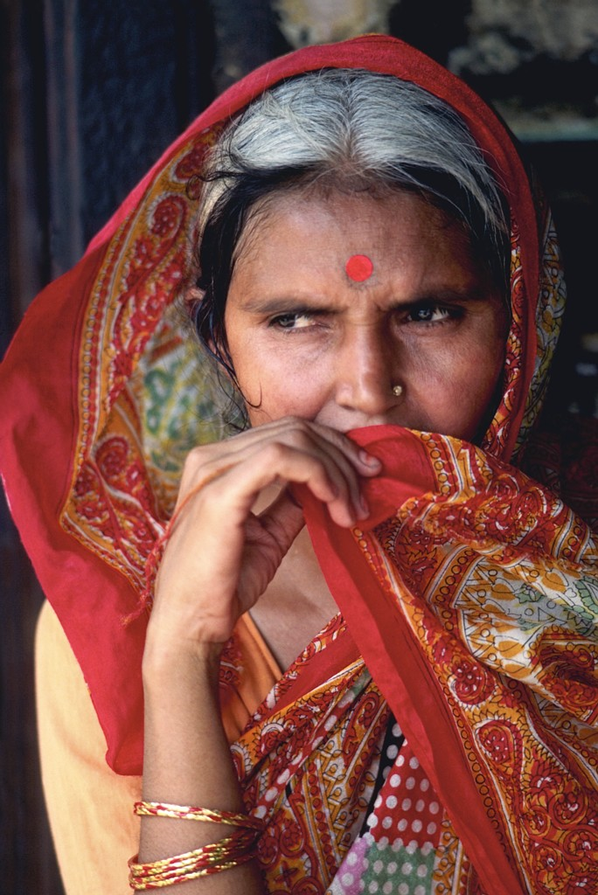
THE FOREHEAD DOT
It is the “third eye” representing a religion of spiritual insight and wisdom. It is also a beauty mark in the culture; young girls have black and married ladies red.

