
The Journey Studies

At Oak Village

A LITTLE REVIEW …
The first five books of the Old Testament were written under the supervision of Moses. In addition to being called the Torah, they’re also known as the Pentateuch (Pentad - five), or The Books of the Law. These five books cover human history from the Creation (perhaps @ 4,000-8,000 B.C.) to the time when Joshua is ready to lead Israel into Palestine in about 1405 B.C.

Joshua, Judges and Ruth record Israel first settling in Palestine (Canaan), getting comfortable, forgetting God, facing God’s discipline and returning to Him. The Books of Samuel, the Kings and Chronicles record the rise and fall of Israel’s three kings – Saul, David and Solomon – and the defeat of Israel by the Assyrians, and Judah by the Babylonians. The Jews escaped a holocaust under Esther, and returned from Babylon to set up the Temple (Ezra) and the walls (Nehemiah).

The Old Testament also contains poetry and wisdom literature and the sermons of the prophets during the epochs that the historical books cover.

WE’RE STARTING THE THIRD ERA!
In Study #3, we said that there were roughly nine Old Testament eras. The first was the Creation Era, which included the creation, fall of mankind, the flood and Babel (from @5,000 BC to 2,200 BC). The second era was the Patriarchal Era, in which we slowed way down and looked at the lives of Abraham, Isaac, Jacob and Joseph (from 2,166 BC to 1,931 BC).

In Exodus, we begin the … guess … the Exodus Era! This era lasts 120 years (the lifetime of Moses from 1520 BC to 1405 BC) but spans four books of the Bible! In this era, we’ll cover
- The birth and early life of Moses (Exodus)
- The Passover and Exodus of the Hebrews from Egypt (Exodus)
- The Law of God (Exodus and Leviticus)
- The Tabernacle (Exodus)

- The refusal to enter Canaan (Numbers)
- The wandering of the Hebrews in the wilderness (Numbers)
- The preparation of Joshua to lead the people (Deuteronomy)

The Great Pyramid at Giza, Egypt

Overview Of Exodus
32

EXODUS

KEY PLACES IN EXODUS
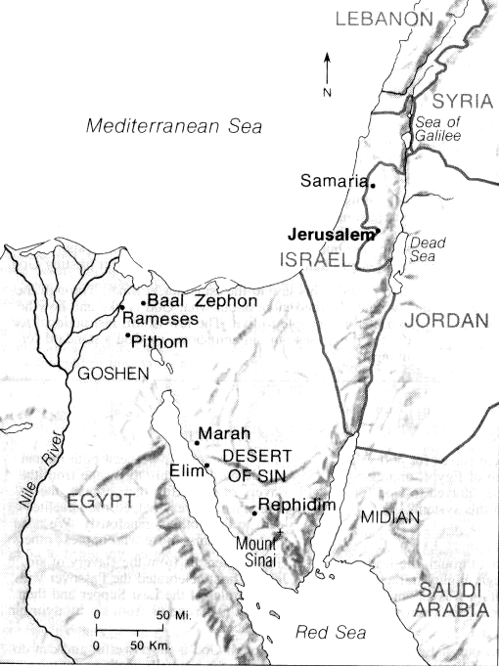
Everything in the next four books of the Bible takes place on the map to the right. The modern names of nations are included for reference.

We learned toward the end of our Genesis studies that a famine drove Jacob and his sons to Egypt looking for food. Joseph had forgiven them for selling him into slavery years earlier, and saw that God had planned for him to come to Egypt so that God could save his family from dying of hunger.

The Hebrew family, numbering _____, settled in ____________, a fertile area separate from the Egyptians. As the centuries went by the Hebrews grew to about _____________ strong! Because they posed a threat to the military security of Egypt, they were made slaves.

Moses spent his first 40 years in Egypt, and his second 40 years in ________ (edge of Saudi Arabia). Jehovah heard the cries of His people, and after a miraculous deliverance, the Hebrews followed God and Moses west, then south to _______ _______ where they received the Law.

Then they headed north to ________, but were afraid of their enemies and refused to take the land. So, God made them wander in the ___________ ___ ____ (zeen) for forty years until the new generation was ready to obey God. God supplied the needs of 2 million people in the desert through all of this time!

KEY PEOPLE IN EXODUS
We will be introduced to people named Moses, Miriam, Pharaoh, Pharaoh’s daughter, Jethro, Aaron, and Joshua.

KEY DIVISIONS OF EXODUS
- Israel in Egypt (1:1-12:30)
- Israel in the Desert (12:31-18:27)
- Israel at Sinai (19:1-40:38)

The Book of Exodus contains more miracles than any other book in the Old Testament. It is the stuff movies are made of! We will look at many themes during these studies such as slavery, deliverance, leadership, worship, selfishness, redemption, law and morality, miracles, stubbornness, jealousy, idolatry, judgment, God’s holiness, courage, fear, etc. Don’t miss it!

Homework:

Read Exodus 1 & 2

What caused the change in Egypt’s attitude toward the Hebrews?

How does the Exodus 2 narrative differ from the movie, “The Ten Commandments?”

