
The Journey Studies

At Oak Village

WHERE’S THE INTRODUCTION?
Notice that the book starts right in without explanation. In the Hebrew, the first word could be translated “and” or “now” meaning that the writer means this to be a natural continuation of Genesis.

WHO ARE “THE CHILDREN OF ISRAEL”
We’re going to hear this term a lot. In Hebrew culture, any descendant of yours was your “child,” and any forefather was your “father.” Jacob (meaning “deceiver”) had been renamed Israel (meaning “Prince with God”) after he wrestled with the angel in Genesis 32:28.

Exodus 1:1-4 mentions Jacob’s sons, but verse 7 mentions that “the children of Israel” increased abundantly – lots of kids, and grandkids, and great grandkids, etc! God commanded Adam, Noah and Abraham to be fruitful and multiply, so this ease in Hebrew women having children is a sign of God’s blessing.

THE PROPHECY ABOUT SLAVERY
God told Abraham in Genesis 15:13-14 that his descendants would serve another country 400 years, and then God would judge the host country. This was about 180 years before it happened.

THE FRETFUL NEW KING
There is much debate over who this king was exactly. The 70 Hebrews came to Egypt during the famine in about 1875 BC. According to historians, the _________ peoples soon attacked and drove the Egyptians south out of Egypt! They were foreign, Semitic invaders from the Middle East who didn’t use hieroglyphics. They ruled for a hundred years or more until the Egyptians, likely led by Amosis I of the 18th Dynasty, ousted them.
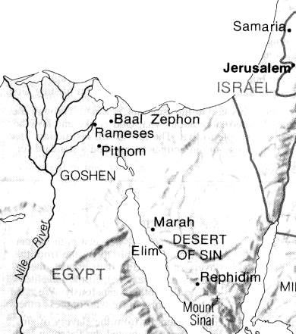
Pharaoh Amosis was not familiar with the story of Joseph or how the Hebrews got there, but he knew they were from Canaan. He likely feared that another Middle Eastern group like the Hyksos would attack Egypt and enlist the help of the Hebrews. So he put the Hebrews under taskmasters (pictured as men with whips and giraffe necks in Egyptian art), and they were used to eventually build the cities of __________ and ___________ (on the border of Egypt and Goshen) during the 19th Dynasty.

But weak and unhealthy people still produced lots of children!

Delivery Of A Deliverer
33

EXODUS

BIRTH CONTROL – EGYPTIAN STYLE!
Read Exodus 1:15-21, the first account of a pogrom against the Jews.

Who were Shiphrah and Puah? Why only two women?

Why did they apparently have this job according to verse 21?

What did Pharaoh command them to do? Why?

What does Romans 13:1-4 tell us about government leaders?
WANTED
DEAD OR ALIVE

MOSES
Why then did these ladies disobey the king?

What do Acts 4:19-20 and 5:29 say about conflicts between the commands of government and the commands of God?

THE BABY ON THE DOORSTEP
Read Exodus 2:1-10. A descendant of Levi, Amram, married Jochebed. They had three children together: _________, _________ and ___________.

He was beautiful, but after ___ months, mom couldn’t hide this little boy. So she prepared an ark of bulrushes coated with pitch. Notice that she didn’t sit in despair, nor did she crusade. She came up with a plan that might work and trusted God. Jochebed likely knew who lived downstream, and sent ___________ along to find out what God would do. What did the girl suggest to Pharaoh’s daughter?

In what way is the story different than Cecil B DeMille’s movie, “The Ten Commandments?”
1.
2.
3.

At what age did Moses likely go to live with Pharaoh’s daughter?

HELPING GOD
Read Exodus 2:11-15. Moses obviously knew that he was a Hebrew – but he was well educated. There is nothing to indicate that he was raised with Pharaoh’s son or was slated as possibly the next Pharaoh.

Perhaps Moses was impatient with God. We get in big trouble when we try to “help God.” Moses killed a man! Others didn’t see it as ethnically motivated. Pharaoh didn’t care. He put out a death warrant and Moses became a fugitive.

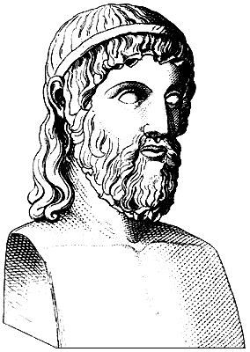
Homework:

Read Acts 7:20-30

How long was Moses in Egypt? How long in Midian?

Why did God take so long with Moses? So long to deliver Israel?

