
The Journey Studies

At Oak Village

A SIMPLE SHEPHERD
We learned last time that Moses married into the family of Jethro, the priest (sheik) of Midian. He spent 40 years tending sheep and goats in the desert of Midian to learn simplicity and humility – to become a person God could use.

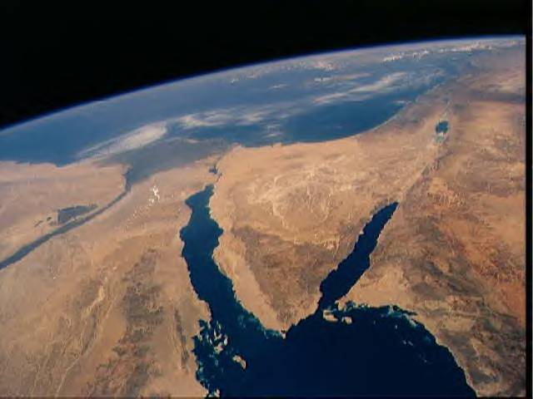
GOING TO SINAI
Read Exodus 3:1-3. Moses moved his sheep southward into the Sinai Peninsula to “the back” of the desert, a mountainous place known as Horeb (meaning desert). There is a mountain there with triple peaks known as Sinai. St. Catherine’s Monastery is at the bottom, and it’s about a 2-hour hike to the top.

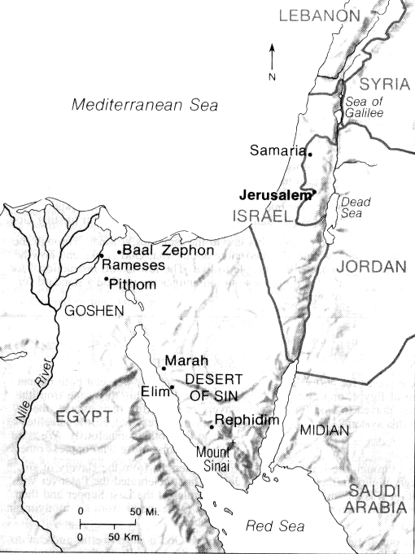
SEEING THE BURNING BUSH!
While in this area, Moses saw a bush that was burning, but not burning up. It was a miracle! What is a miracle?
- Literally, a miracle is a _________
- Broadly, a miracle is anything that happens against the ________
- Specifically, a miracle is something done by supernatural purpose and design that is _______ to the laws of ________

Given this definition, we will see a lot of miracles in Exodus! Can we really believe these stories, or are they just myth? We have to wrestle with several things to believe:
- Public Opinion. Remember, that in our “scientific” era, anything that cannot be observed, measured and repeated is not believable (except evolutionary theory). Man intuitively senses that there is a God, and must work to rationalize God away.
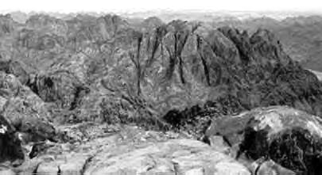
- Atheistic Theologians. Many theologians are atheistic philosophical scientists who do not believe in God and doubt anything supernatural. For instance, they say here that Moses saw a mirage, or a bush with red leaves or the campfire of some Bedouins! Come on! He had lived in the desert 40 years!
- Is Your “God” Too Small? If God created the universe, what is there that he can’t do? Unlike the sinful and fearful Greek gods, the God of the Bible has no trouble changing the natural laws that he created.

The Calling Of Moses
35

EXODUS

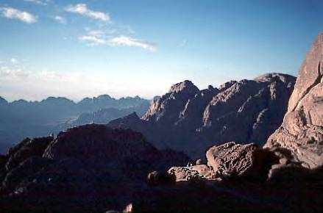

THE GRAND INTRODUCTION
Read Exodus 3:4-6. Moses knew very little about who God was. He was the nameless God of Adam, of Noah – fathers of the human race – but more specifically, he was the God of Abraham, Isaac and Jacob. At this point, the Hebrews called him, “He Who Has No Name.”

God knew Moses by name. Imagine God calling you by your personal name!! What two things did God tell Moses to do?
1.
2.
Why would God tell Moses this?
What made this ground “holy ground?”
What was Moses’ response?

GOD DECLARES HIS PURPOSE
Read Exodus 3:7-10. Remember the anthropomorphisms? God had seen, heard, and come down to rescue Israel. In verse 8, God mentions the Land of Canaan in three different ways: God’s purpose was to get them out and move them back to the land he had promised to Abraham 550 years earlier.

Verses 7-9 build the need for God’s intervention. Moses may have wondered why God was telling him this, but there was no doubt when God spoke the next sentence (verse 10). Moses was to be God’s emissary to lead Israel.

MOSES’ FOUR BIG OBJECTIONS
Moses was a manager-type. Over the years, he had learned to look at the details or weather and wind and signs of disease in his livestock. When God said that Moses was “the man,” Moses started thinking through what might happen.

Moses brings up four issues and God patiently answers him, until the last one, where Moses was apparently “grasping at straws.”
  - Objection #1 – Who Am I? (3:11-12)
God’s Answer – I will be with you. You will make it back here.

  - Objection #2 – What is His Name? (3:13-22)
God’s Answer – My name is Jehovah, the self-existent one. There will be resistance and I will bring you out with miracles.

  - Objection #3 – They will not believe me. (4:1-9)
God’s Answer – I can do miracles through you to add credibility.

  - Objection #4 – I am slow of speech. (4:10-17)
God’s Answer – I will give you the words. Your bother Aaron will be your spokesman.

THE NAMES OF GOD ARE CONNECTED WITH “EL”

El – Powerful One (singular)

Elohim – Powerful One (singular or plural)

El Roi – The God who sees
- - -
Bethel – House of God

Peniel – Face of God

Homework:

Read Exodus 5-7

How would you describe the level of success of Moses’ first meeting with Pharaoh?

Why would God allow such a setback when He sent Moses to Egypt?



What Is God’s Name? The answer God gave to Moses was four Hebrew letters - YHWH – which means literally “I am because I am.” The four letters are called the Tetragrammaton.

God’s name gives us a characteristic that only God can have – he is totally and eternally self-existent. No created thing can say that. People exist because parents gave birth to them; things exist because of a creator.

Although Yahweh is the best pronunciation, the Hebrew scribes used the vowels in the Hebrew word “lord” (Adonai) to form the word Jehovah.

