
The Journey Studies

At Oak Village

GOD’S “FIRSTBORN”
Read Exodus 4:18-23. In v. 22, God tells Moses to mention that Israel is God’s “firstborn.” What does that mean? Ancient cultures had the custom of “primogeniture,” where the first male child would inherit everything.

If that son, was a loser, your name would be forgotten, so fathers often treated the first as the favorite and gave them teaching and attention. Culturally, the term “firstborn” came to mean much more than simply born first.
FIRSTBORN = _______________

The nation of Israel was God’s “firstborn.” Many years later, Jesus was called the firstborn, and the New Testament writers used a term meaning “prototype” – the model, the most important, the form others should follow.

GOD TRIES TO KILL MOSES?
Read Exodus 4:24-26. This is really a strange story! Remember that in Genesis 17:9-11, God decided to distinguish his chosen people from other people-groups by ______________. It became the distinguishing mark of the Hebrews in ancient times (even though it is now common in first-world cultures).

In his marrying and blending in with the uncircumcised Midianite people, Moses apparently chose not to circumcise Gershom. God had apparently mentioned to Moses that if he was going to lead Israel, he needed to set a proper example. Moses was either refusing to do it or putting it off … so God increased his incentive.

- Was God really trying to kill Moses?

- Why did God wrestle Jacob in Genesis 32:24-28?

MEETING THE LEADERS OF ISRAEL
Read Exodus 4:27-31. Whom did Aaron gather together?
- Who were they?
- Who did the speaking?
- What was the response of the people when they realized that God was finally going to do something about their affliction?

Meeting Pharaoh
36

EXODUS

A NOT-SO-GREAT FIRST MEETING
Read Exodus 5:1-21. For the first time, Pharaoh is introduced to the God of the Hebrews, “Thus says Jehovah, God of Israel, ‘Let my people go …’” Pharaoh’s response was predicted by the Lord, but he was also a bit cynical. He refused to recognize any god of slaves, a god who obviously had no power to free the Hebrews.

Moses softened the command to a plea the second time, and asked to go about 3-day’s journey into the desert (about ____ miles) to offer sacrifices. Read Exodus 8:25-27 and answer why they had to go 3-day’s journey.

Pharaoh twisted this to mean that the Hebrews had 3 idle days on their hands, so he gave them more work! Now they had to collect straw for the bricks and not let the tally drop! The elders tried to intercede, but negotiating failed. Moses was to blame for all of this.

“HOUSTON, WE HAVE A PROBLEM”
Exodus 5:22-23. Notice that Moses didn’t lash out at the elders; he went to God. This is an indication of Moses’ meekness. Imagine Moses’ emotional state at this point! His wife was angry with him, he had left his secure home, Pharaoh despised him, the Hebrews were now more mistreated than ever, and the elders bitterly blamed him! How humiliating! What was God doing?
MEEKNESS = WEAKNESS
Meekness is _________ on ________ rather than ________.

Moses started thinking, “God, I told you so…” He didn’t accuse the Lord, but honestly and respectfully asked “Why this, and why me?”

GOD IS IN CONTROL
Read Exodus 6:1-12. It seems that all throughout the Bible, God’s answer is the same – “I am in control. I will not stop human evil or suffering, but I can use it for my purposes.” But notice that God didn’t even answer Moses’ questions! God just talked about
Homework:

Read Exodus 5-7

How would you describe the level of success of Moses’ first meeting with Pharaoh?

Why would God allow such a setback when He sent Moses to Egypt?

- His____________
- His ____________
- His ____________

The verbs in Exodus 6:6 are actually in the _____ _______ tense. Verse 7 has the first mention of “I will be your God, and you will be my people,” a phrase God often repeats to Israel.

What was the response of the people to God’s reassurances?
Did Moses feel any more confident about speaking to Pharaoh?
What does it mean to have uncircumcized lips?

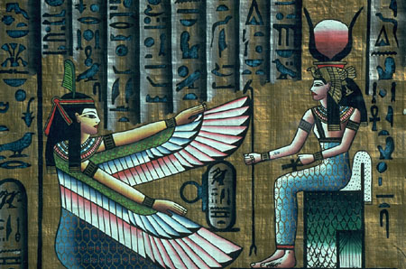

CNN Poll - Moses’
Popularity Poll

Day 1 Day 2

Homework

Read Exodus 7-10 and list the 10 plagues!

On which times did Pharaoh harden his heart? On which times did God harden his heart?

What can that teach us about obeying God?

