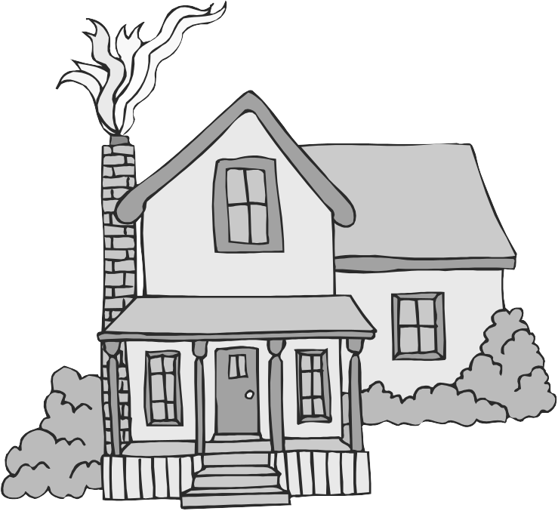
The Journey Studies

At Oak Village

AN EXCHANGE OF DEATH PROMISES!
After the ninth plague (darkness), Moses again spoke with Pharaoh whose heart was being hardened by the Lord due to his earlier stubbornness. This was a heated exchange. Read Exodus 10:28-29 to see what Pharaoh said.

Remember that in the original Hebrew language, the story was written fluidly, without chapters and verses. Exodus 11:1-3 is a parenthetical thought – something God had told Moses beforehand. Moses continues his comments after 10:29 in Exodus 11:4-10. Moses spoke “the word of the Lord,” and did so with great anger. Why was Moses angry?

THE BLOOD OF A LAMB
At this point, God is getting ready to exercise His severest judgment against Egypt. In the ancient culture, the firstborn was a symbol of power and all gods were firstborn. Jehovah would come at midnight on April 14th and kill every firstborn. What could stop this penalty of death?

Remember from our studies in Genesis 3 and 4 that God allowed the shed blood of a sacrificed lamb to temporarily cover the sins of a person. Every follower of God since Adam offered up sacrifices to God periodically, admitting their sin and believing God would forgive them.

Read Exodus 12:1-13. The only thing that could cause the “Destroyer” to pass over you was following the orders that the Lord gave:
- Kill a _________ ___________ without ___________.
- Take a branch of _________ and put apply the blood to the _____________ and the _______________ of the house.
- No one was to leave the house until _____________.

Notice that the death of the lamb was not enough. The blood needed to be personally applied. Believers were to eat the lamb together with ________ _________ and _____________ ___________ and were to be dressed and ready to go!

Escape The Death Angel
38

EXODUS

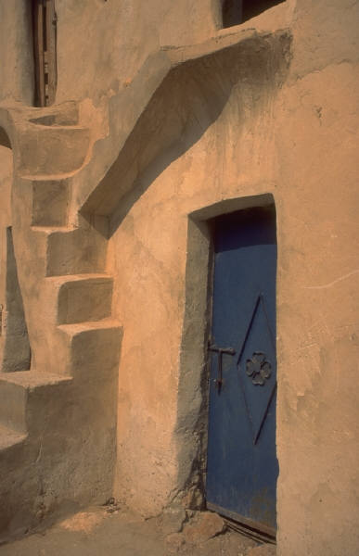

UNLEAVENED BREAD
This is the first mention of leaven (yeast) in the Bible. In various verses, leaven is a symbol of evil, hypocrisy, worldliness, evil conduct and false doctrine.

The Feast of Unleavened Bread and the Passover were the first ceremonies given to the people of Israel. They were given as an everlasting ordinance!

THE DEATH ANGEL COMES
Read Exodus 12:29-32. While the other plagues may have used nature and secondary agencies of nature, this 10th plague was due solely to the Lord. It came at midnight on the 15th of the month of Abib.

There are several Pre-Mosaic Pyramid texts and coffins excavated in Egypt that refer to “the night of the slaying of the firstborn.” Almost every house was affected.

Pharaoh summoned Moses and told him to take the Israelites away – not just for 3 days either! Then he concluded with an amazing request in verse 32. He asked Moses to bless him. This was at least a temporary recognition that Moses God was God, and Pharaoh hoped that no more plagues would come.

PREPARATIONS FOR THE EXODUS
Read Exodus 12:33-42. Exodus means ___________________. What kind of gifts and supplies did the Egyptians give to the Israelites?

About how many Hebrew men were there when they left Egypt?

So, the people of Israel were about how many in number?

How many had entered Egypt many years before?

How long had the people of Israel been in Egypt? ________ years.

What year was 430 years ago for us? _______ Anyone know what life was like here back in those days?

THE TYPOLOGY IN PASSOVER
Christians see in the Passover many elements of the gospel.
- God was going to judge people with death. Romans 6:23
- Jesus was the Lamb God provided to fully take away sin. John 1:29
- Death of the lamb meant nothing unless applied personally. John 1:12
- None of the lamb’s bones were to be broken. Gen 12:46, Jn 19:31-37

Homework

Read Exodus 13:17-14

Can you figure out which direction the Israelites took out of Egypt?

What time of day did the Red Sea crossing take place?

What method was God using to lead Israel?

