
The Journey Studies

At Oak Village

GOD’S PROGRESSIVE INTRODUCTION
God is an eternal spirit, the creator and sustainer of all things, and therefore greater than all things. We don’t know Him very well, and people who study the Bible all their lives just begin to scratch the surface of who He is.

At this point, the Hebrews knew God as the God of Abraham. They had just learned that His name was Jehovah (I AM BECAUSE I AM), and that He was powerful enough to cause the plagues that embarrassed the Egyptian gods and tore Egypt to shreds! Israel comes to experience God in a powerful way in Exodus 13 and 14. Millions of Hebrews are now assembled near the town of Succoth, near the city of Rameses, ready to leave Egypt.

THE PILLAR OF CLOUD AND FIRE
Read Exodus 13:17-22. Whose bones did the Hebrews take with them out of Egypt?

Read Genesis 50:24 and Exodus 4:31. How did Joseph know what would happen?

How far was it from Rameses to Mount Sinai? ______ miles

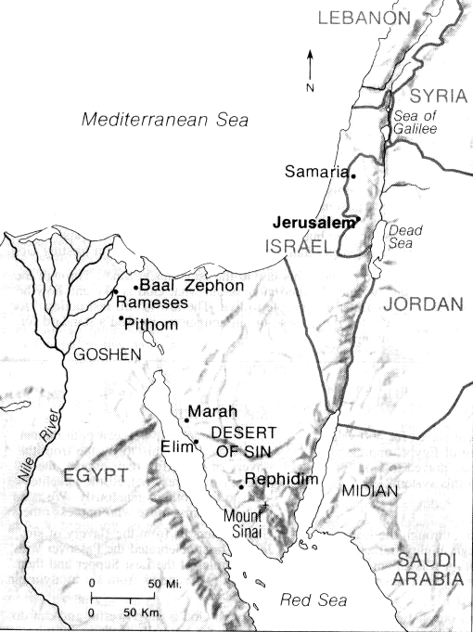
Why did God lead Israel southeast instead of on the main trade route along the Mediterranean, which was the shortest way to the Promised Land?

Imagine seeing a manifestation of God! Here for the first time, the people could look up and see that Jehovah was with them! He appeared as a:
PILLAR OF _________ BY ____________
PILLAR OF _________ BY ____________

This is known in the Hebrew as the ____________ glory of the Lord. It is a visible and luminous indication of God’s presence. Can you think of other places in the Bible where it appeared?
- Leviticus 16:2 _______________________
- 2 Chronicles 5:11-13 _______________________
- Luke 2:9 _______________________
- Matthew 17:5 _______________________

Exodus From Egypt
39

EXODUS

PHARAOH IN HOT PURSUIT
Read Exodus 14:1-12. Israel didn’t do so well in its first test of faith! Faith can be contrary to both sight and reason. Faith sees that God is doing something beyond what I see; my job is to obey Him and not panic. But our natural tendency is to rely on sight. Read Matthew 14:25-32.
Just as the Lord said, Pharaoh started to loathe the fact that he had let 4 million slaves go free, and God responded to his sinful heart by giving him more hardness – an irrational stubbornness! When the people of Israel saw 600+ chariots coming, following God became second to panic. Notice the order of events:
- They were afraid
- They cried out to God
- They started to blame others, especially leaders
- They said that they were innocent and misled
- They looked back on their “golden” past

LEADERS RESPOND TO GOD
Read Exodus 14:13-20. We can see that, despite his bold proclamation in verse 13-14, Moses cried out to God. He didn’t start arguing with the people. He pointed them to stillness, quietness, patience and faith in God.

Notice that God refers to himself as “the angel of God” in verse 19. The cloud went between the Egyptian army and Israel. What was unusual about this pillar (v. 20)?

THE PARTING OF THE SEA
Unbelieving scholars hate this incredible miracle witnessed by 4 million people, and have tried to explain it away – it was a marsh, it was a dry year, there was an earthquake and an upheaval of land … Verse 22 is clear that there was a wall of water on the right and on the left. Verse 28 is clear that seasoned soldiers all drowned in the water.

THE SALVATION OF THE LORD
There is an incredible analogy here.
_____________ is an unbelieving world
_____________ is Satan, the evil hardened ruler of the world’s system
_____________ is someone who is captive to sin, who God is going to save
_____________ is the evangelist, one who says that God can save
_____________ is the Holy Spirit leading the captive to salvation
_____________ is the place of faith and commitment
_____________ is the place of learning about God
_____________ is the place of victorious living and serving God
Notice that the waters had to part. We cannot save ourselves – it took a miracle of God. Notice in verses 21, 22 and 27 that, as Israel walked through on land, they went from darkness to light!

Homework

Read Exodus 15 – 17:7

How important is praise and thanksgiving?

What were the two big tests Israel faced?

How did they respond to the situation God ordained?
LOGISTICAL MIRACLES
Part 1

The crossed the Red Sea in one night. If they went double file through a narrow path, the line would be 800 miles long and it would take 35 days and nights to get through! There had to be space 3 miles wide so that they could walk 5000 abreast to get over in one night. When they camped, the campground was 2/3 the size of the State of Rhode Island – 750 square miles!

