
The Journey Studies

At Oak Village

A LESSON ON WORSHIP
Read Exodus 15:1-18. In Exodus 15, we have a great song of worship. No doubt there was spontaneous cheering when the sea drowned Pharaoh’s army, but this was probably written for the celebration that followed. Some people have a grim idea of worship, but what is worship, really?

WORSHIP = “WORTH-SHIP”

Worship is telling someone about their incalculable worth to you, telling them how incredibly incredible they are, telling them about their wonderful characteristics. We hear “worship” of people all the time in our culture. What are some instances of this?
- ____________________________________
- ____________________________________
- ____________________________________

Worshipping God does not come easy to sinful people. Some, like Satan, have been hardened by sin and refuse to even recognize a god higher than themselves, let alone worship one. Some who are aware of their sin feel embarrassed to talk to God. Normally, you have to be obedient and confident of God’s love to worship Him easily and naturally. Israel was following God and was very confident of His love for them at this point!

THE SONG OF MOSES
Moses also wrote Psalm 90. In Exodus 15, the focus is on Jehovah – his special name is mentioned 10 times. There are three divisions:

Verses 1b-5 | A proclamation to the people about what happened and about how great the Lord is.
Verses 6-13 | Moses addresses the Lord in pure worship (notice the repetition of “you” and “your.”
Verses 14-18 | A prophecy about what will happen in the future, given the Lord’s track record in the past.

Moses’ sister, Miriam, picks up on the spirit of the song and adds a chorus (from verse 1) with tambourines and dancing.

Our Daily Bread
40

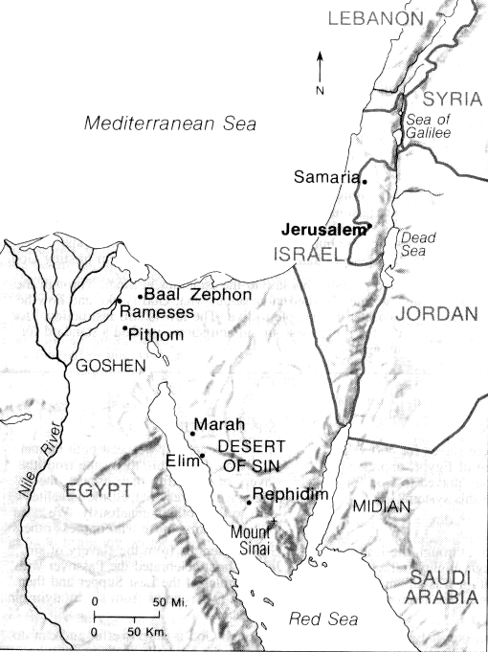
EXODUS

Worship is expressing the high value of the one loved.

TEST #2 – NO WATER
Read Exodus 15:22-27. Israel didn’t do so well in its first test of faith when they were stuck between Pharaoh and the Red Sea! So how did they do with test #2? With two exceptions, every mention of the word “murmuring” or grumbling in the Old Testament has to do with when Israel followed God.

They traveled about 42 miles south through the Wilderness of Shur (a stony desert followed by blinding white sand with the _____ of ____ on the right and mountains on the left), about 11 miles per day, and ran out of water.

The sickening waters of ________ were enough to make them forget all of the miracles of the past few weeks. They didn’t pray to God; they grumbled to their leaders. God showed Moses a tree. Perhaps the change in water was a miracle, or perhaps, as the Arabs claim, certain thorn bushes can counteract the sickening levels of minerals in the water. Still, God showed them the answer!

TEST #3 – NO FOOD
Read Exodus 16:1-31. Again Israel grumbles and starts pining for Egypt – a direct slap in God’s face.

What did God send in the morning? ___________
What does that name mean? ________ ___ ___
Describe it’s properties:
- _______________________________
- _______________________________
- _______________________________

How much were they to gather each day?
How much was an average portion? An omer = _______ quarts
What happened if they gathered more?
What happened each Friday morning? Why?
What came at night for the Hebrews?

Why did God send this gift of food from heaven in exact portions with all these restrictions?
- To develop a ________ dependence on Him.
- To show them His ______________ provision.
- To ________ them and to see if they would _________.

How well did Israel obey the Lord in this simple thing?

How long did Israel eat mannah (v. 35).

LOGISTICAL MIRACLES
Part 2

Leading 2-3 million people requires a lot of food. According to a Quartermaster General in the army, it is reported that Moses would have to have had 1500 tons of food each day (taking up two freight trains a mile long). This food would have to be cooked over fires requiring 4000 tons of wood from a desert without much wood (more freight trains). If everyone had a glass of water and washed a few dishes or clothes it would take 11 million gallons of water each day!


Man, did we take a wrong turn or what?

Homework

Read Exodus 17 – 18.

What is the significance of striking the rock?

Who were the people of Amalek (Genesis 36:12)?

What was Jethro’s suggestion?

