
The Journey Studies

At Oak Village

TESTING GOD
Read Exodus 17:1-7. Our greatest natural desire is to be the God of our own life so that we can control everything and everyone and thereby experience happiness. We get angry, sad or frustrated when that doesn’t happen … unless we give up on being God.

Many people are their own God, but they believe there is some kind of supernatural being in heaven. When the going gets tough, they instinctively try to get the supernatural God to fix things, and to increase the incentive, they say, “If you really exist, you’ll do X. Prove to me you exist by doing X.” This makes God into a subservient genie-of-the-lamp. This is called “testing God.” God hates it and normally refuses to act.

When the water ran out again, Israel did this. They said, “Kyeah right, where is God? If He is with us, why isn’t He providing water?” They didn’t respond with submissive prayer to the God who had proven performance of provision. They got angry. This was more than complaining – it was a wrangle. They called the place Massah & Meribah – Testing and Contention.

WATER FROM THE ROCK
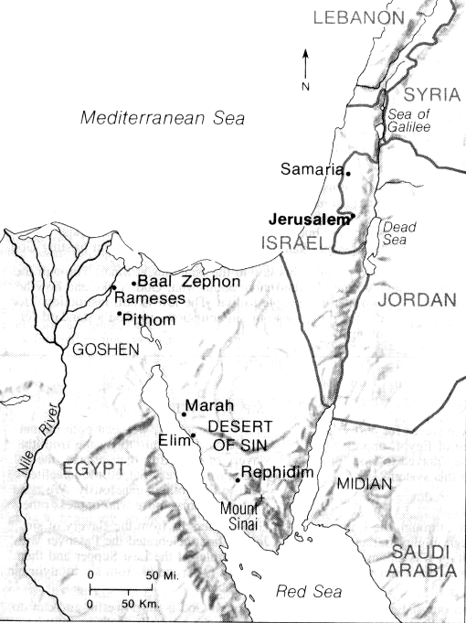
Today, Wadi Refayid (see Rephidim on the map) is a little stream that flows in this area except in the dry season. When Israel came it was dry. Moses, as he often did, went to Jehovah – these were God’s people, not Moses’. Moses and the elders (leaders of each tribe) went ahead. Moses’ rod was the symbol of God’s authority. He struck the rock once, and from it waters flowed that brought life.

Read 1 Corinthians 10:1-6. The rock that Moses struck was a symbol of whom?

What does it mean when it says that Christ followed them?

What do we call an appearance of Jesus Christ in Old Testament times?
A _______________________

What did Jesus say about himself and water in John 4:4-15?

Relying On God & Others
41

EXODUS

THE WAR WITH AMALEK
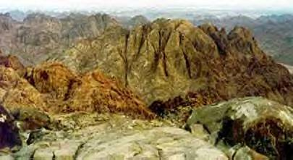
Read Exodus 17:8-16. Who were the Amalekites according to Genesis 36:12? Historians tell us that they were a fierce nomadic tribe that lived in this desert area and made their livelihood by conducting raids on settlements and caravans. They killed for pleasure. Israel had some treasures of Egypt – nice booty! So, in came the raiding parties.
A view of the hills near Rephidim

Here we are introduced to Joshua for the first time. He is a military man who will (40 years later) succeed Moses as Israel’s leader when they go into to conquer Canaan. His name – hoshea – means “Jehovah is salvation.”

Read Jeremiah 9:23-24 and Psalm 20:7. There are no “odds” or “chances” with God. The battle is the Lord’s; if we are failing, he is trying to teach us and help us grow to depend upon him more. God had preserved them from thirst and starvation; here He shows He can preserve them from defeat.

Moses takes “the rod of God” (the symbol of God’s authority) on top of an overlooking mountain and holds it up … as long as he could (hold out a small book for 2 minutes). The Bible doesn’t say that this encouraged the troops, nor that Moses prayed while holding it up. Stretching to God was an appeal to Him (as a child would do) for victory.

Who helped Moses hold up his arms?
What does that teach us about spiritual leadership?

THE JETHRO PRINCIPLE
Read Exodus 18:1-27. Moses got a visit from his father-n-law, a sheik of Midian, someone with some experience in organization. Jethro spots a problem with Moses that is typical of conscientious leaders – failure to delegate. “No one can do this as well as I can. I am indispensable.”

Not only is this not true of the leader, it can also build too much dependancy on one person – something that will wear out both the leader and the people.

His suggestion – use broad leadership! What were the qualifications for the men who would act as judges?
- _______________________
- _______________________
- _______________________
- _______________________

In verse 23, Jethro gave wise counsel – use this idea if it’s alright with God. Apparently it was, and Israel used the plan from then on.

Jehovah
Homework

Read Exodus 19 and 20.

What is the “conditional promise” God makes to Israel?

How did God underscore the incredible importance of what was about to happen?

List the 10 Commandments. Is there any natural division to the list of 10?

