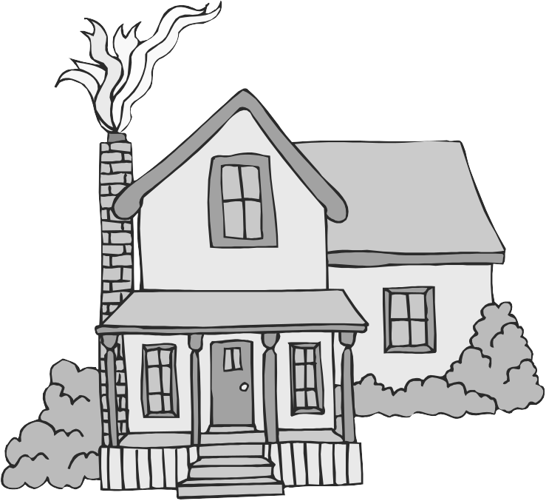
The Journey Studies

At Oak Village

GOD TO DWELL ON EARTH!

Read Exodus 25:1-9. God invites the people of Israel to give an offering of material things in order to build God a “dwelling place” (tabernacle), so that He could manifest His presence to His people rather than just hovering above them in the pillar of cloud and fire.
- Who had the design for the shelter?
- Notice anything about the quality of the materials?
- Why didn’t God ask them to build Him a Temple?

FIRST THE FURNITURE
The specifications for the furniture of the Tabernacle are in Exodus 25-27.
The Lord used cubits - a cubit is about 18 inches or 1/10 millionth the distance from the poles to the center of the earth. Notice anything special about how some pieces were decorated?

44
God’s
Tabernacle

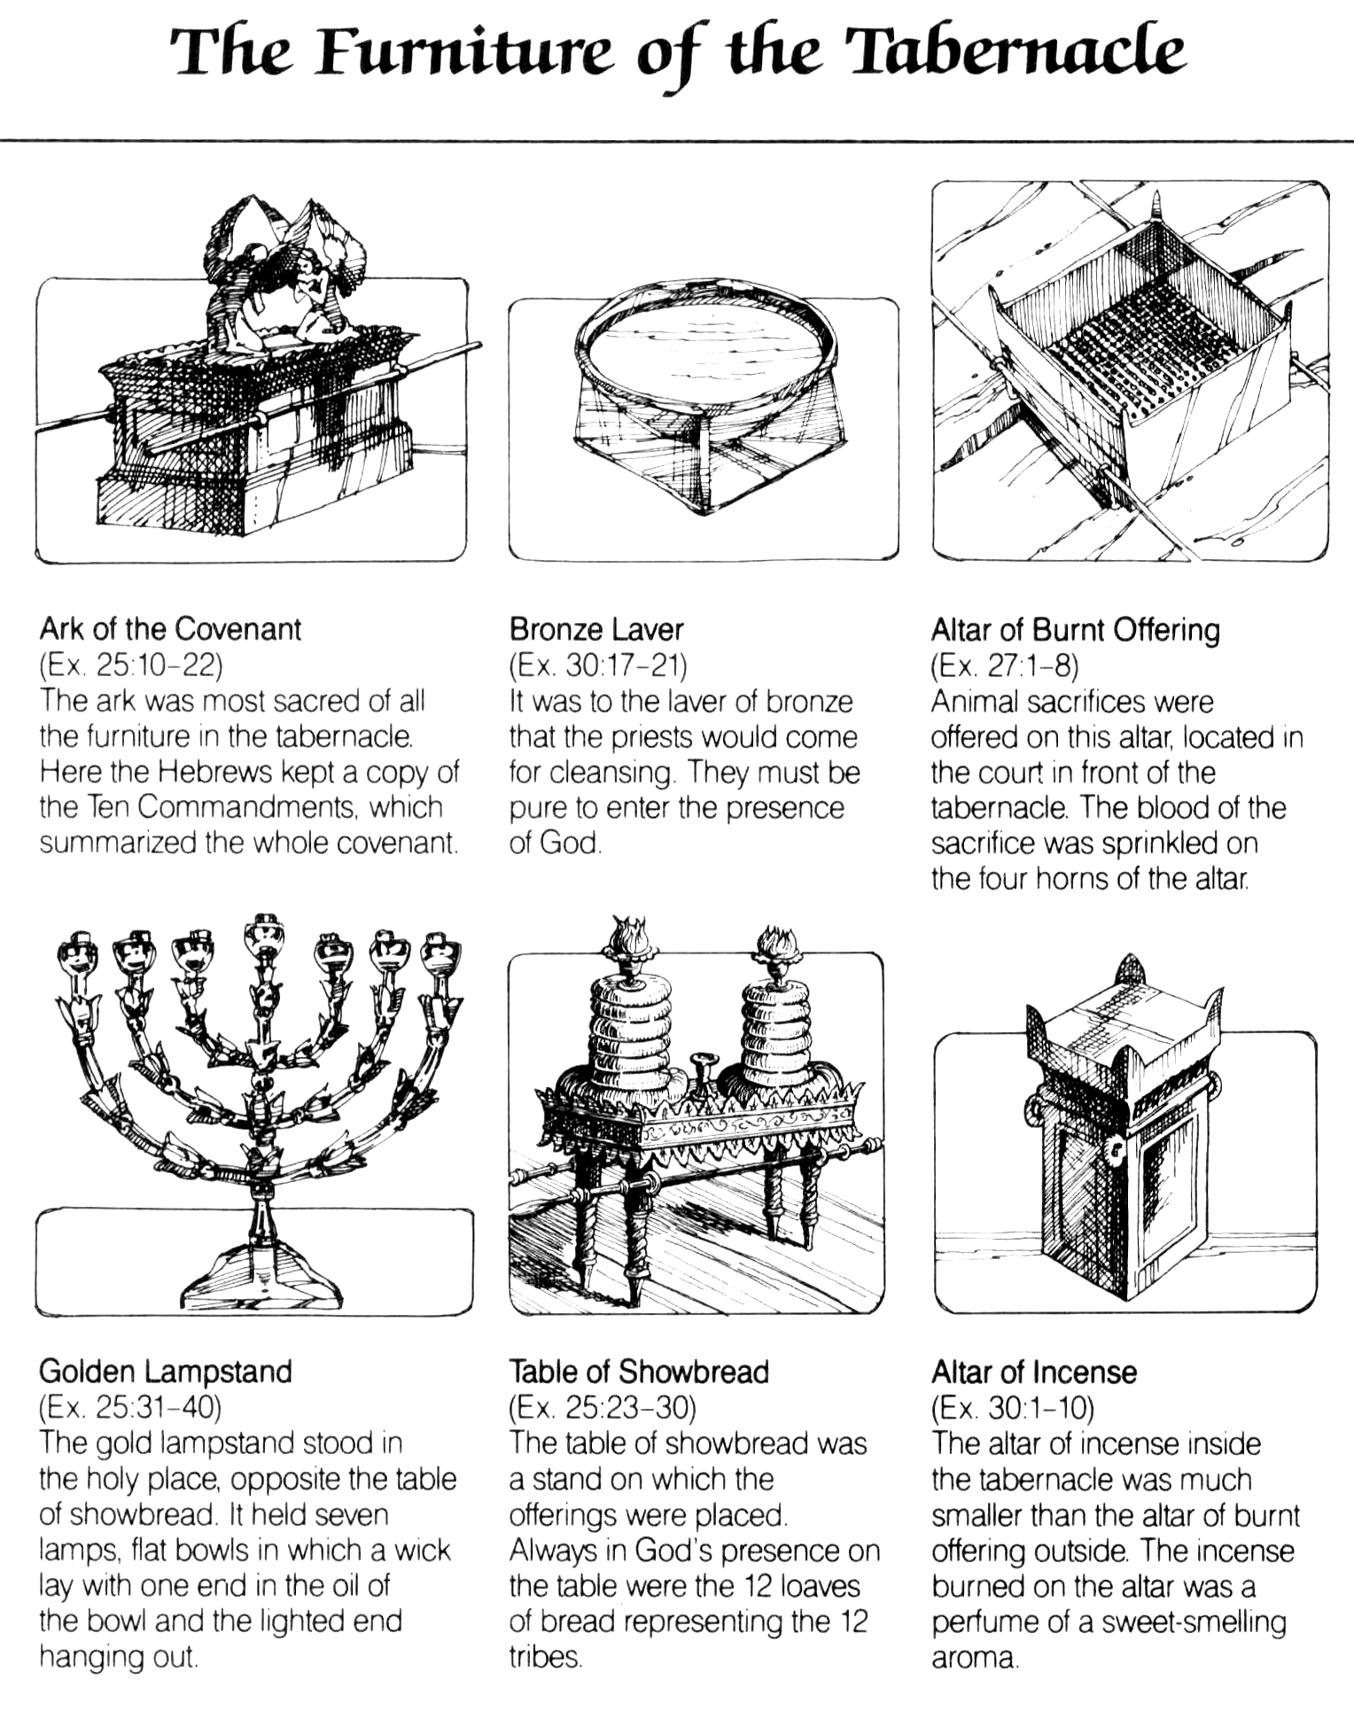
1
2
3
4
5
6
EXODUS
AN ONLINE REFERENCE

www.templebuilders.com has a lot of cool pictures and sketches.
From Nelson’s Complete Book of Maps and Charts
God On Glass

Hey, let’s not miss the theophany in Exodus 24:9-11. Compare this description with that in Revelation 4:1-6.

How does this story mesh with John 1:18?

THE TENT OF MEETING
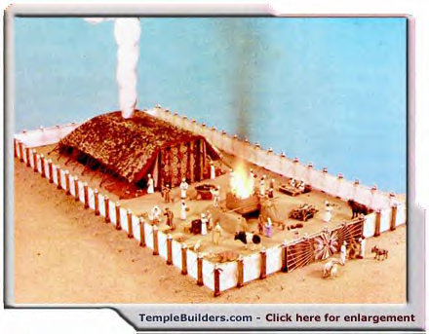
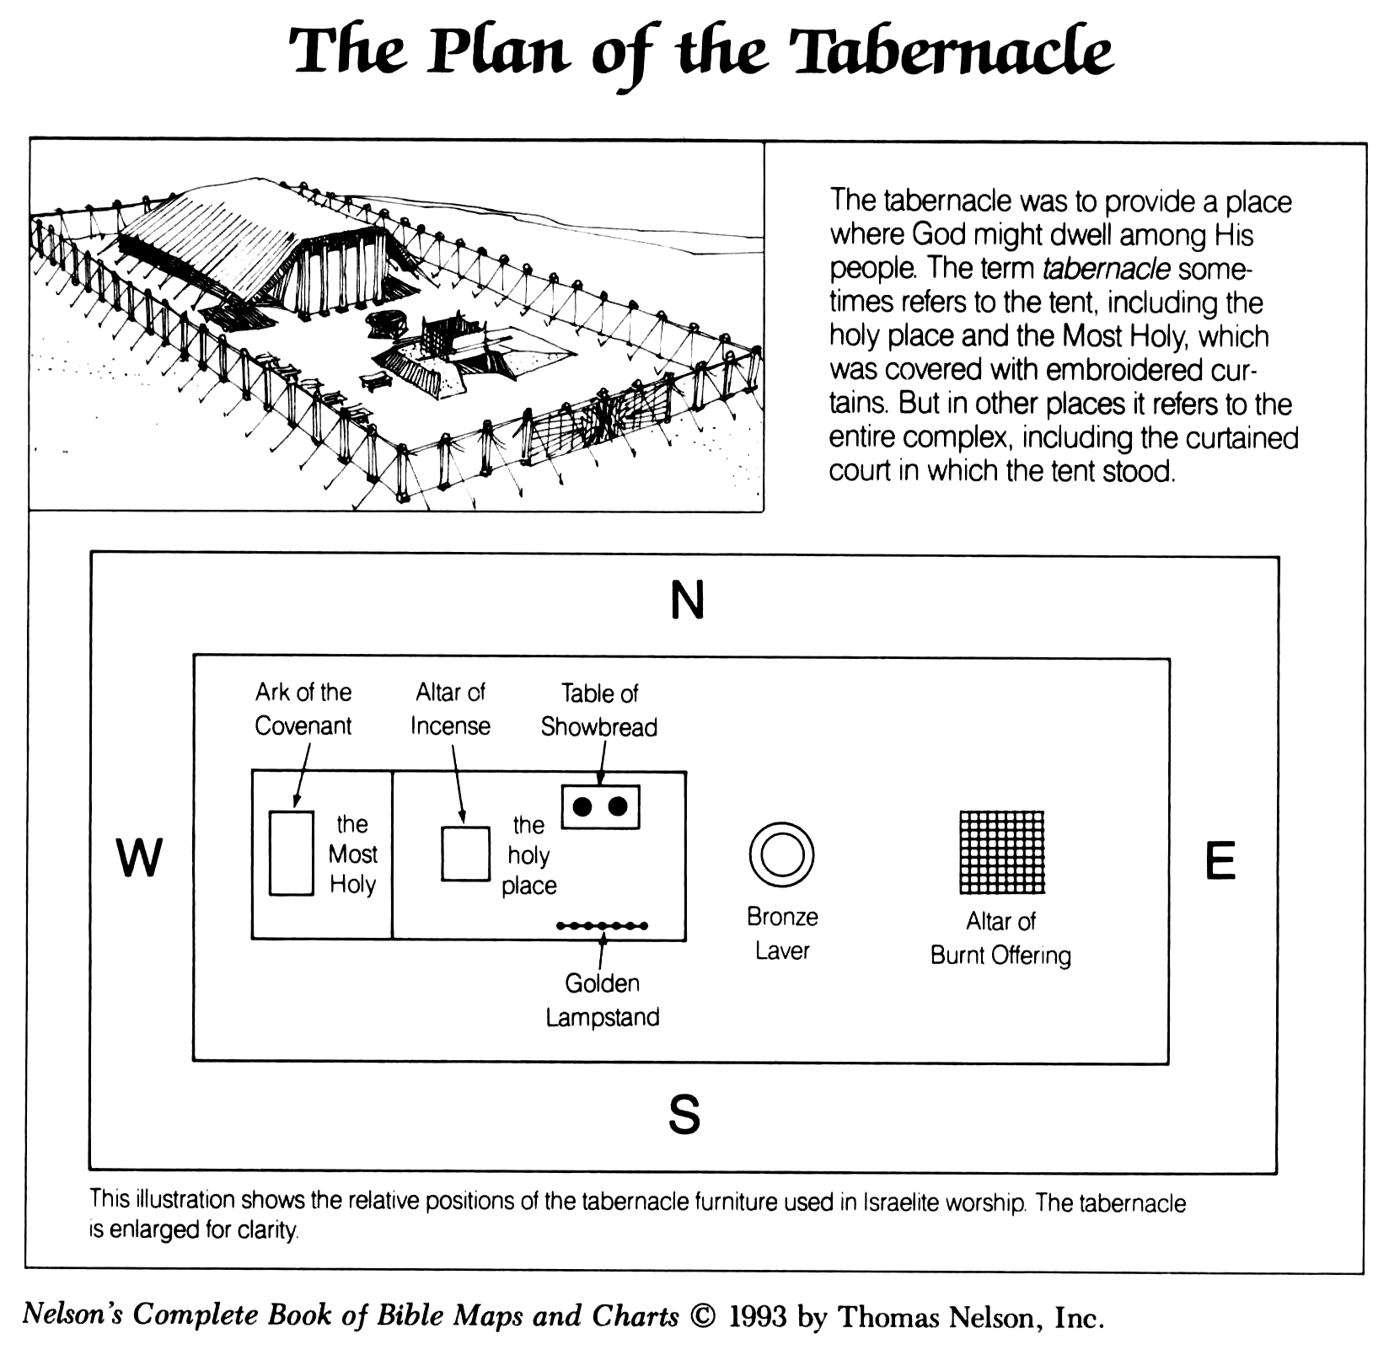
Read Exodus 26:1-7. The Tent of Meeting was fit together without nails and could be easily and repeatedly dismantled for travel.
- What colors were used in the fabric for the curtains?
- What material shielded the outside of the tabernacle from the sun and rain?

Read Exodus 26:31-35. The Tent of Meeting was divided into two main rooms divided by a thick curtain or veil.
- What were the names of the rooms?
- What was in each room?
- What was woven into the veil?
- How often did the priest enter the outer room? The inner room?

THE COURTYARD
Read Exodus 27:9-11. Around the Tent of Meeting was a courtyard with the entrance facing eastward. The Tent and the Courtyard were together known as the Tabernacle. Three tribes encamped on each side of the Tabernacle.

Read Exodus 31:1-6.
- Who were the guys that would make all of this stuff?
- What had God done to prepare them for this artistry?
- Where had God most likely given them these skills?
- What does that teach us about the hard times we go through?

THE PRIESTLY GARMENTS
Read Exodus 28:6. What was an ephod?
According to verses 9-10, what was engraved on the two onyx stones?
According to verses 16-21, what stones were on the breastpiece?
What were the Urim and Thummim in verse 30?
According to verse 31-35, what was on the hem of the priests robe and why?

WHY ALL OF THE DETAILS?
God is not interested in man coming up with his own ways to discover God (like Cain in Genesis 4). To keep them from idolatry and error, God gave them details. Also, the gold and purple emphasize God’s royalty, majesty and value; the blue reflects the heavens, red, the sacrifices.

Read Hebrews 9:1-15, and 23-28. The Tabernacle was an earthly model of what? How many times did Christ offer his flesh and blood?

Homework

Read Exodus 32-33.

What was the “sound of war in the camp?”

What was Aaron’s unlikely excuse?

What did Moses ask God to do for him?

