
The Journey Studies

At Oak Village

TWO-MINUTE REVIEW
We saw in Genesis 3:1-7 that Satan mixes truth with lies when he tempts. All he wants is for us to act in our own self-interest against God’s commands. Sometimes we are tempted and sin when we crave and live for possessions, for pleasures and for positions of notoriety. How could something beautiful, tasty and full of knowledge be wrong? It feels so right!

THEIR EYES WERE OPENED
What does Genesis 3: 7 mean when it says, “their eyes were opened?”

What did they do when they realized what had happened?

What do you do when you’ve sinned?
- I don’t tell anyone | - I make an excuse
- I look both ways or hide | - I take responsibility for my action
- I hope no one finds out | - I shift the blame

What does Romans 2:14-15 tell us about people who have never heard of God’s law of right and wrong?

What do we call this law of right and wrong that is written in our hearts and offers its opinion, whether or not we care to listen?

Would murder be wrong even if there were no written law against it? Why?

GOD’S SEARCH FOR US
The next morning, God was “walking and talking” in the Garden. If God is a spirit, what are two possible explanations for this?

If God is everywhere and knows everything, what was God doing? What does this visit teach us about God?
- God is ____________! He could have __________ them instantly.
- God is the ___________, not ____. Romans 3:10-12.
- Sometimes God _______ until we experience the __________ of what we’ve done.
- God asked ____________ to allow Adam to _________ his sin.
The word “repent” means to _________ ___ _________.
The word “confess” means to _____ the _____ _______.

Changed By The Fall
9

GENESIS

Mercy is not getting what we deserve.

Grace is getting what we don’t deserve.

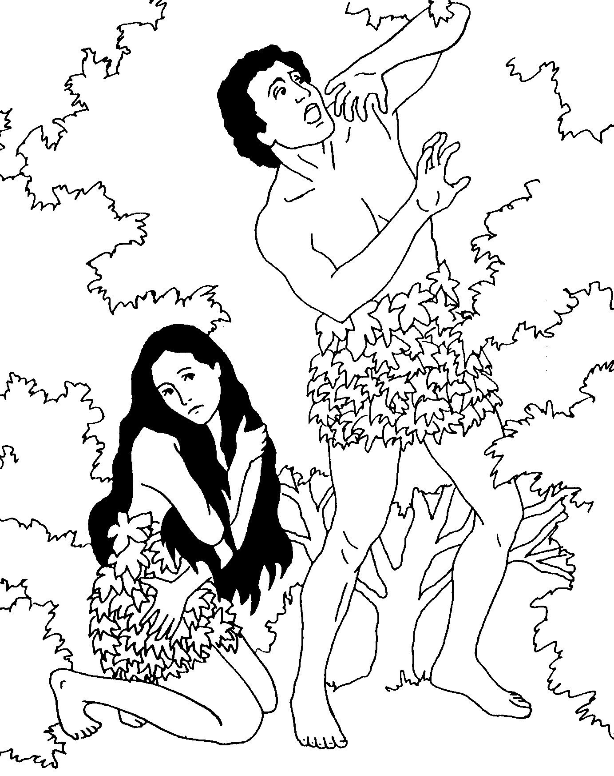
INCREDIBLE! BLAME-SHIFTING!
Did Adam and Eve repent and confess? The first evidence of their sinfulness was hiding. “Passing the buck” was the second evidence of their sinfulness. Who did Adam blame? Who did Eve blame?

Do I have to sin? Who else is responsible for my actions?

A CURSE ON CREATION
Understand that God could have destroyed creation and started over. Why couldn’t God have said, “Awe, let’s just forget about this little slip. But don’t do that again.”

As a curse, did God strike them with sinfulness?
Fill in the parts of the curse:
Serpent | Woman | Man & Earth
Genesis 3:14-15 | Genesis 3:16 | Genesis 3:17-19
1  2  3 | 1  2 | 1  2  3

NEW COVERINGS
In Genesis 3:21, what did God make to cover Adam and Eve? What had to take place for them to receive animal skins?

PARADISE LOST
Genesis 3:22-24 is one of the saddest passages in the Bible! God drove Adam and Eve from the Garden. Why?

What two things were placed there to keep them from ever entering again?

Far worse than losing the Garden of Eden, Adam and Eve also lost what?

GOOD NEWS IN THE CURSE?
Genesis 3:15 is an interesting verse! Certainly most women don’t like snakes!
- Notice first that the enmity (hostility) is between the serpent’s offspring and the offspring of the woman (not the woman and man).
- The verse moves to the singular – “he will crush your head, and you will strike/bruise his heel.” It seem that the rivalry will come down to an event involving one man!
- The rabbis see this as the first proclamation of a coming Messiah!

Homework!

Read Genesis 4.

Why do you think God wouldn’t accept Cain’s sacrifice?

