
The Journey Studies

At Oak Village

THE SECOND ADAM AND EVE
We learned last time that after the Lord had brought the animals to Noah (7 each of sacrificial animals; 2 each of non-sacrificial), they got them into the ark and waited seven days. Then God it began to rain, and God shut the one door of the ark (Gen. 7:16). The fountains of the great deep were broken up, and the rains poured down for 40 days and nights.

When the judgment came, there was only one ark, and only one door to the ark. God had been patient for hundreds of years, but then judgment came. God’s judgment is often connected with natural disaster in supernatural timing (the Flood, Sodom, the last Tribulation), and He gets His people out before judgment falls. Noah, his wife, his three sons and their wives were the only humans on board when God shut the door. We are all their descendants. All humans are of one race – the human race.

NUMBERS IN THE BIBLE
The Bible was written over a 1600-year period by over 40 authors. One amazing thing to note throughout the Bible is the use of numbers. For instance, 4, 40, and 400 are numbers of testing or judgment.
- The rains of Noah’s Flood lasted 40 days
- Israel was captive in Egypt for 400 years
- Israel wandered in the Wilderness for 40 years
- After Israel returned from captivity, God was silent for 400 years
- Jesus was tempted after a 40-day fast

Three (3) is the number of divine perfection (the creative order reflecting God Himself, some would say):
- Time is one, yet three – past, present and future
- Space is one, yet three – height, depth and width
- Matter is one, yet three – solid, liquid and gas
- Temple had three parts – sanctuary, holy place, the court
- Human beings are three – body, soul and spirit
- Human abilities are three – thought, word and deed
- Stable furniture – three legs

THE FLOOD RECEDES
After 7 ½ months, the ark rested on Ararat (modern-day eastern Turkey – about 17,000 feet tall). After 40 more days, Noah sent out a raven and a dove. The dove returned; the raven didn’t. Why? Seven days later, the dove came back with an olive leaf; seven days later, she left and didn’t come back. There was enough material to begin nesting.
A Covenant With Noah
15

GENESIS



THE FIRST ALTAR
Eager and thankful to be back on terra firma, everything and everyone left the ark (Gen. 8:18-19) after 371 days. No doubt overwhelmed with what God had done, Noah reaffirmed his commitment to God by building an altar (a large pile of stones) and offering up burnt sacrifices to cover the sins of himself and his family. Abraham and Moses will later also make altars to God after He saves them from great destruction.

WHAT IS A COVENANT?
A covenant is an agreement that creates a family relationship. It is not a contract, which can be dissolved by the mere agreement of the parties. To dissolve the covenant, one of the parties must violate one of its provisions, and a higher authority must make a decree ending the covenant.

What are two examples of modern covenant relationships?
1.
2.

THE FIRST TWO COVENANTS
Covenant | Description
Edenic Covenant | Populate the earth, take dominion over the earth, care for the Garden of Eden, and do not eat the fruit of the tree.
Adamic covenant | Serpent and Satan are cursed, Satan will be judged by a Messiah, labor in childbirth, subjection to husband, ground is cursed, and eventual physical death.

GOD’S COVENANT WITH NOAH & MANKIND
What were the terms of this covenant?
- God says He will never destroy all life again or radically change the nature of things on earth again (Gen. 8:22 and 9:11-12).
- Noah was to be fruitful and multiply (Gen. 9:1 and 7).
- Noah was to take dominion over the earth and animals, and was permitted to eat meat, but not meat containing blood (Gen 9:2-4).
- The sacredness of human life was reaffirmed, and the death penalty was added as a deterrent (Gen 9:5-6).

What was the sign of the covenant? ________________
Where was it located? _______________
For whose benefit is it? ________________
When is there not one on earth? _______________

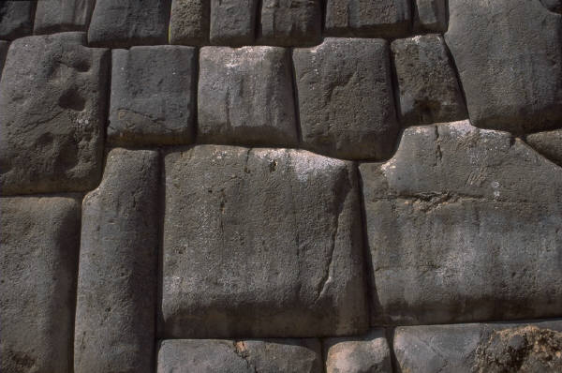

Stone from an altar

Homework!

Read Genesis 9-11

Who did Noah curse?

Why is this story another evidence that the Bible could not have been written by people alone?

Where was the Tower of Babel?

