
The Journey Studies

At Oak Village

KEEPING EVERYONE TOGETHER
Genesis 10:8 mentions that a man named Nimrod came from Ham’s line (grandson). He began to be a mighty warrior on the earth, and was a mighty hunter. In ancient days, kings were hunters and protectors of the people.

The Jewish Talmud (commentary) gives a different spin and says that Nimrod was a hunter of people – he tried to keep people together, and made war to combine clans. He was the founder of the biggest of the ancient cities – Babylon in the south and Nineveh in the north.

THE MOTHER AND CHILD
Remember Genesis 3:15? The destroyer of the evil tempter would be the offspring of a woman, but not a man – the child of a virgin. Even the first constellation in the ancient calendar was Virgo – the mother and child. After the Flood, it didn’t take long before leaders attempted to gain earthly honor by claiming to be gods or spokesmen for the gods.

Ancient Babylonian Religion
Chief god - _________, had a wife named ___________.
Nimrod claimed to be the virgin-born son of Semiramis, and so was born what is known as “the cult of mother and child.”
Ancient Egyptian Religion
The goddess ______ was a virgin who gave birth to _________
Ancient Greek Religion
The goddess _______ was a virgin who gave birth to _______
Ancient Hindu Religion
The goddess ________ was a virgin who gave birth to _______
Ancient Canaanite Religion
They had a “queen of heaven” that the Jews worshipped (Jeremiah 44:15-25).

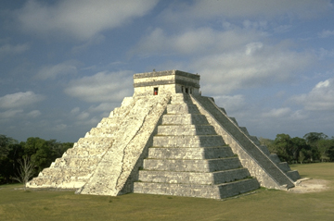
Those who study ancient religious history say that Christianity must have borrowed its virgin-birth ideas from these ancient religions. Christians see the ancient religions as attempts to counterfeit what God said He would do in Genesis 3. If God’s Word had stopped at Genesis 3, any one of those religions could be the right one, but God kept revealing the plan for His great promise when He chose Abraham, then Isaac, then Jacob and so on.

Revelation, chapters 17-18, reveals that the great false religions of the earth, known as “mystery Babylon,” will kill many followers of Jesus, but in the end be destroyed.
Confusion At Babel
17

GENESIS

STUDY TIP 

Understanding “The son of”
When the Hebrew Bible uses the term “the son of” it refers to anyone in a person’s lineage. Thus, in the family below, it could be said that Peleg was the son of Noah, or Noah begat Peleg.

NOAH

Ham Shem Japheth

Cush Arphaxad

Nimrod Shelah

Eber

Peleg

THE UNITED NATIONS
Genesis 11:1 tells us that the whole earth had one language. Makes sense since they were all from one family! What was the language?

Verse 2 says they settled in the ancient land of Shinar is what we call what today? ___________________

According to verse 4, what were the two goals of the leaders in building a tower?
1.
2.

What were the two problems God saw with their building this tower?
1.
2.

According to verses 7-9, what did God do?

MAKING A NEW NATION
According to Genesis 11:27-32, where was Abram from?

What was his background?

Was he a Jew?

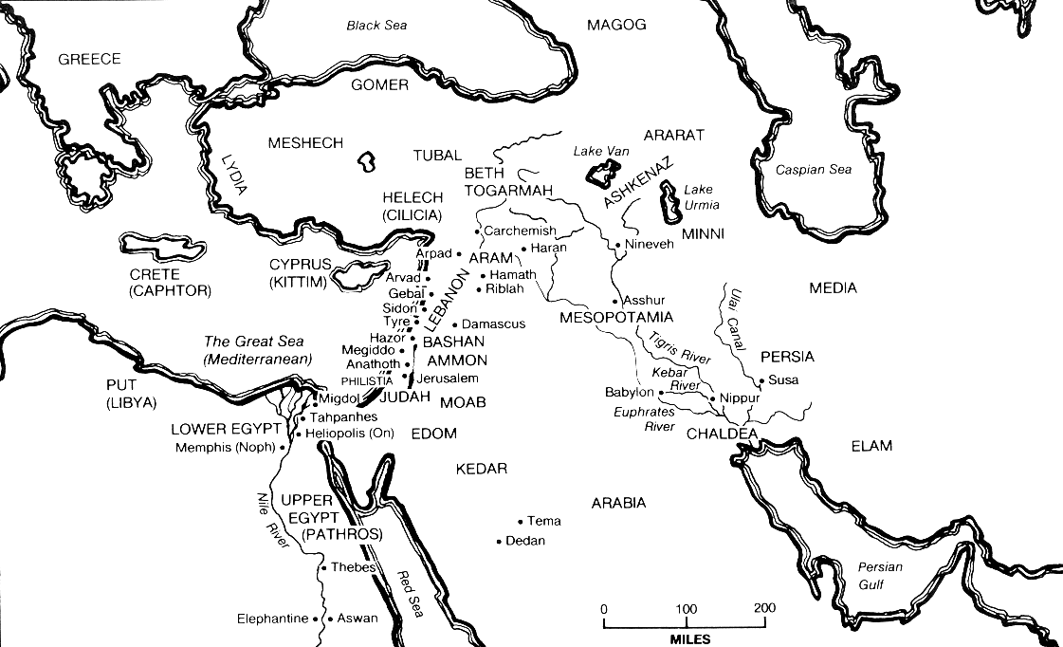

The Genesis writer again uses an anthropomorphism in verse 5 “God came down.”

In verse 7, God also uses “us” for the third time in Genesis when speaking to Himself. With whom is God speaking?

Ancient “Shinar”
Later Sumeria
Later Chaldea
Homework!

Read Genesis 12

List the parts of God’s covenant with Abraham.

Where did God tell Abraham he was going?

