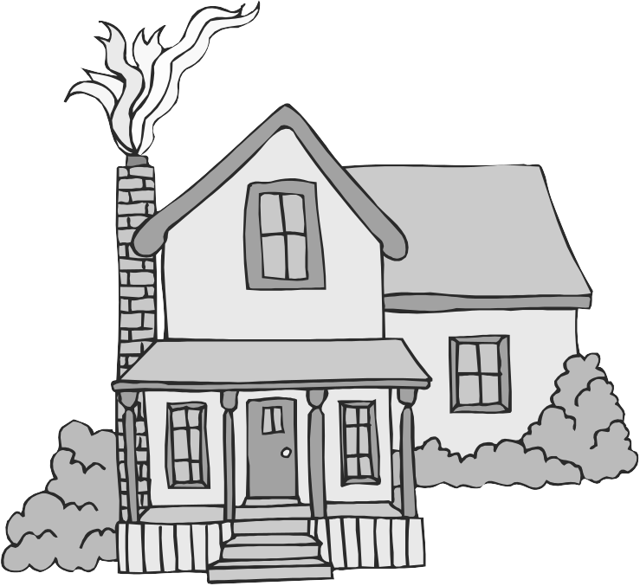
The Journey Studies
Jacob’s Tough Lessons
28
GENESIS

At Oak Village

FIRST THE BIRTHRIGHT; NOW THE BLESSING!
The years went by and Isaac grew old. It was nearing the time for the old father’s final blessings upon his children. “Blessing” is a lost art form that we do not understand in the West. However, just try blessing your children or friends and they will instantly respond.

The Hebrew blessing is often repeated in Scripture. It was felt that God honored a father’s blessing in the life of the child. What are the elements of a blessing?

ELEMENTS OF BLESSING
- _______________ ________________of the person
- _______________ of the person’s _________
- A ____________ about the person’s _______ and ____________
- Projecting a _________ of a ___________ future for that person
- Meaningful ____ _________ and _____________ _________

Is there such a thing as “curse?” How do parents curse their children?

Read Genesis 27.
Who were the parties that perpetrated this terrible deception?

How did this event fulfill a prophecy made to Rebekah before the twins were born?

WHERE TO FIND A WIFE?!
Rebekah complained to Isaac in 27:46 that she would just die if Jacob married a Canaanite, so Isaac sent Jacob packing to look for a wife back east in the northern Euphrates valley with Uncle Laban.

Read Genesis 28:1-5. Even without deception, what did Isaac do for Jacob before Jacob left?

JACOB’S LADDER
As he headed home, Jacob stopped for the night. According to verse 11, what did he use for a pillow?

What did God promise Jacob? Have we seen these promises before?

What was Jacob’s conditional promise?

THE MEANING OF NAMES

Isaac - Laughter
Esau – Hairy
Jacob – Replace by deception
Bethel – House of God

JACOB’S LABOR OF LOVE
This is another beautiful girl and another love story! Read Genesis 29:1-12. What was Rachel’s family’s occupation?

Hey, what’s the deal with kissing and crying in verse 11?

Read verses 15-20. What was the difference between Rachel and Leah?

What was the deal made between Jacob and Laban?

Read verses 21-30. What did Laban do to Jacob?

This is known as “poetic justice,” but the truth is that God often sends us people just like ourselves to teach us about ourselves. How were Jacob and Laban similar?

So, how many years in total did Jacob work to get the wife he wanted?

THE BATTLE OF THE WOMBS!
Read Genesis 29:31 – 30:24. What is the Lord’s view of the unloved?

List the children borne by the two wives and their maidservants. These names may sound familiar to you – they are the fathers of the twelve tribes of Israel:

Leah | Rachel
 | (Bilhah)
 | (Bilhah)
(Zilpah)
(Zilpah)
 | (Rachel dies)

Homework:

Read Genesis 31-33.

With whom did Jacob wrestle?

Why did Jacob flee from Laban?

How did Jacob make peace with Esau?

