
The Journey Studies

At Oak Village

THE REBELLION OF KORAH, DATHAN & ABIRAM
Read Numbers 16 & 17. About 250 leaders, led by Korah the priest, challenged the authority of Moses, just like Miriam and Aaron had done. You’d think they’d be smarter! They said, “You take too much on yourselves. All of us are holy, so why are you exalting yourselves?”

Moses bowed down and reminded them of their blest position as rulers of Israel, but apparently that was not good enough for them. So he invited all 250 to come to the tabernacle with incense burners. The ringleaders refused to come, blasted Moses for taking them out of Egypt, and got the whole encampment riled up.

God was ready to destroy them all, but Moses intervened and sent out word for everyone to get away from the tents of Korah, Dathan and Abiram. The ground opened up and swallowed them and their families, and fire consumed the other 250 leaders.

The next day, the people said Moses and Aaron were responsible for killing their leaders. The Lord appeared over the Tabernacle and a plague went out. Moses sent out incense to stop the plague but 14,700 people died before they got around to every house.

The next day, God told the heads of the tribes to carve their names on rods (walking sticks) and put them in the tabernacle so that God could show the people whom He had chosen to lead. They did so, and the next day Aaron’s rod had buds, blossoms and ripe almonds on it! The discussion was over!

MOSES’ COSTLY FAILURE
Read Numbers 20. In time, Miriam died … and they ran out of water, AND the same complaints came about being back in Egypt! Moses and Aaron sought the Lord, and God told Moses to speak to the big rock by the encampment.

Moses went out and said, “Hear you rebels! Must we bring water for you out of this rock? He then struck the rock twice with his rod and water gushed out. What was wrong with what Moses did?

God told Moses that because Moses and Aaron didn’t believe God, they wouldn’t lead Israel into the Promised Land. Why was this punishment so severe? What does 1 Corinthians 10:4 say? Any symbolism here?

49
NUMBERS
Wilderness Wanderings

HEY, NO REWIND BUTTON!

In our lives, there is no rewind, there is no erase, and there is no undo. All is forward play.

How many things have we done, how many words have we said that we would give dearly to take back?

Tomorrow is fresh with no mistakes in it. But when tomorrow becomes today, remember that it will soon be sealed off as yesterday!
SERPENTS AND A BRONZE SERPENT
Read Numbers 21. Israel had to travel around Edom, and they got discouraged. They started waxing lyrical about Egypt again and said they “detested that miserable bread.” So, God matched venom with venom and sent poisonous snakes among the people, and many died. They knew why and they repented and came to Moses for help. According to 1 Corinthians 10:5-13, who was tested by Israel’s sinfulness?

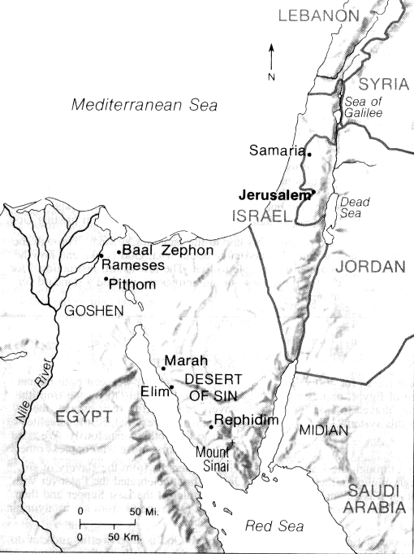
God didn’t take away the snakes! He told Moses to forge a graven image! – a serpent’s image – and put it on a pole and lift it up so that whoever looked on it would live. Who else was “lifted up” between earth and heaven to give life according to John 3:14-18?
Edom
Moab
Ammon

THE TURNING POINT
Numbers 21 seems to mark a turning point for Israel from the old generation. 1) They had their first battle (with Arad) and called on the Lord to help them. God helped them trounce the Canaanite tribe; 2) They repented of their complaining even before Moses interceded for them; 3) They routed Sihon, king of Heshbon; 4) They defeated Og, King of Bashan near the border. Things are looking up!

THE PROBLEM WITH BALAAM
Read Numbers 22-24. Balak, King of the Moabites, saw Israel defeating the cities nearby, so he hired for big bucks a diviner named Balaam to curse Israel. So, God spoke to Balaam and says he couldn’t curse Israel because they were blessed. Balaam tells Balak, who then offers Balaam more money.

The next day, Balaam is riding his donkey to visit Balak, and the Angel of the Lord appeared to the donkey causing her to veer into the wall and hurt Balaam, so he whacked her. The third time the donkey saw the angel, she lay down and he whacked her again. Then the Lord open the donkey’s mouth, and she spoke, and Balaam answered! Read vv. 28-35.

Well, Balak went through the whole religious ceremony, and then Balaam blessed Israel! Balak then moves Balaam to different places, but each of the four times, Balaam pronounces another blessing on Israel!

SIN AT THE BORDER
Read Numbers 25-36. One last blunder occurred when the men of Israel enjoyed having sexual relations with Moabite women as part of worship to Baal, one their gods. A plague struck 24,000 until the offenders were hung.

A new census was taken, the division of Canaan was mapped out, the Law was given a re-codification in Deuteronomy, and Joshua was appointed as Moses’ successor. Conquering Canaan lay ahead, starting with Jericho!

Israel came northeast out of the desert and asked if they could pass through Edom (modern Jordan to the east of Israel), but Edom said no. They stayed to the west, but then went southeast to avoid Moabite towns.

Remember that the Moabites and Ammonites were descendants of Lot, nephew of Abraham. Edomites were descendants of Esau, Jacob’s brother. Still, that didn’t make anybody the friends of Israel.
.

